Wednesday, 1.8.25
OBJECTIVES:
- Find your seat!

- Introduce ourselves.

- Discuss the SAT/ACT Math Prep Syllabus and Course Expectations document.

- Discuss the Classroom Procedures.
- Homework:
- Remember to return your completed Classroom Procedures, signed and dated by both you and your parents/guardians, on Friday, 1.10.25.
(2) Join classroom.google.com for this course. The code is qi54lwy.

- Learn about the new Digital Math SAT Test.
- Class Work/Homework:
https://youtu.be/rPFseETCcKo?si=p5Z7yprYmbrEBcXT
https://satsuite.collegeboard.org/media/pdf/digital-sat-test-spec-overview.pdf
- https://youtu.be/rPFseETCcKo?si=FmADPZwD-xWFQvNW
- https://youtu.be/a7LUE8EQSLM?si=eWPKkiUD1zeZEFJ6

- Know how to answer a student-response question.

Approximately 75% of questions in the Math section use the same 4-option multiple-choice format, while the remainder use the student-produced response (SPR) format.

As the name implies, answering the SPR Math questions means you'll generate your own response and enter it into a response field positioned near the question.

These questions assess your ability to solve math problems with greater independence and with less structure and support than that provided in the multiple-choice format.

SPR questions may have more than one correct response, although you’ll supply only one answer.

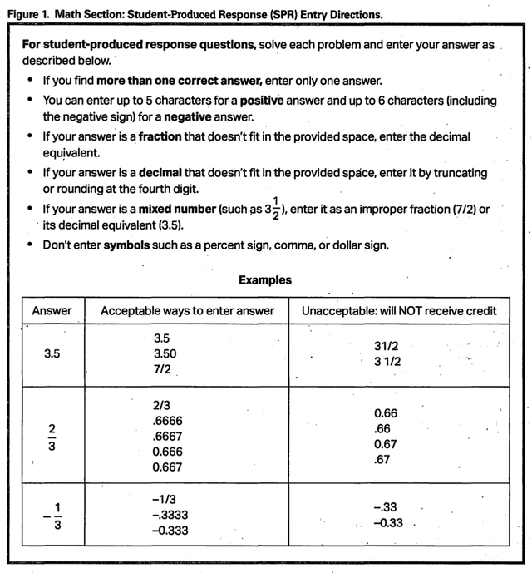

Friday, 1.10.25
OBJECTIVES:
Understand linear models. Be able to do the following:
- Know how to find the intersection of 2 lines.
- Use slope-intercept linear form.
- Use point-slope linear form.
- Use general linear form to graph a line.
- Use general linear form to find the x-intercept, the y-intercept, and the slope of the line.
- Know and use the definition of slope.
- Understand the concept of slope: positive slope, negative slope, indeterminant slope.
- Know the relationship between the slopes of 2 parallel lines.
- Know the relationship between the slopes of 2 perpendicular lines

Turn in your completed, signed, and dated Classroom Procedures Agreement.
Entry Work: Find the intersection of 2 lines, using your TI-84 graphing calculator.
Class Work: Discussion of linear models.
Homework: Linear Models Review (10 Problems) __Handout to be received in class.

